Hands-On
Exercise 9: Implementing the Command Pattern
As part of this module, I successfully implemented, executed, and tested the Command Pattern in Java by developing a project named CommandPatternExample. I created a Command interface with an execute() method and implemented concrete command classes such as LightOnCommand and LightOffCommand to encapsulate requests for controlling a light device. I also developed a Light class that acted as the receiver, providing methods to turn the light on and off, and a RemoteControl class that served as the invoker by holding and executing command objects. After completing the implementation, I ran the program and tested issuing different commands through the RemoteControl to verify that the appropriate actions were performed on the Light object. This hands-on exercise helped me understand how the Command Pattern encapsulates requests as objects, promotes loose coupling between senders and receivers, and provides flexibility in implementing operations such as queuing, logging, and undoable actions.
Coding:
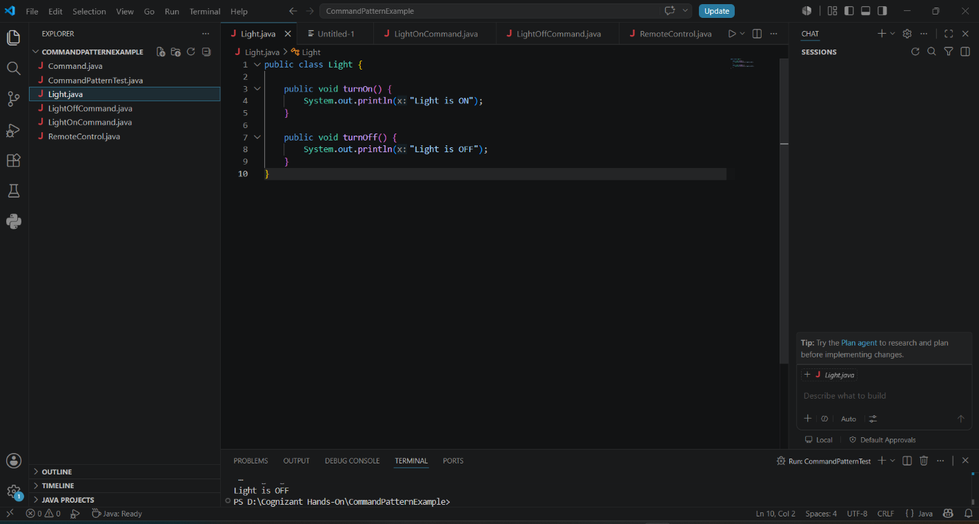
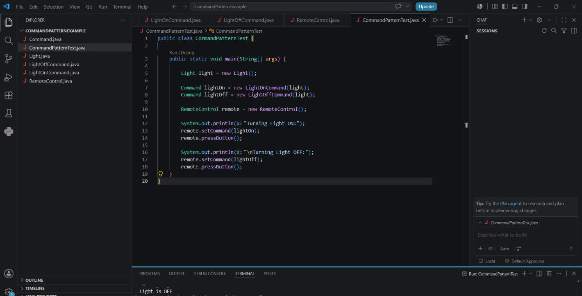
Output:
